**Heights of UT Students vs their Sex and Milk Drank**

**Vy Phan**

**12-11-18**

**SDS 328M**

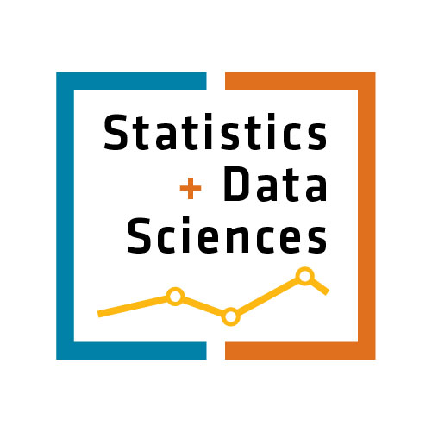

**Introduction**

**Objectives: We know that nutrition plays a role in height growth. However, the goal of this study was to find the correlation between nutrition, specifically milk, and height and how strong the relationship is for UT students of class of 2020.**

**Research Hypotheses:**

Main Effects –

* Ho: μ(male) = μ(female) when controlling for cups of milk drank

Ha: μ(male) ≠ μ(female) when controlling for cups of milk drank

I expected that male mean height will significantly differ from that of the female.

* Ho: Milk does not significantly, linearly relate to total height of UT 2020 students when controlling for sex.

Ha: Milk does significantly, linearly relate to the height of a UT 2020 student when controlling for sex.

I expect that milk does significantly, linearly, positively relate to the height of a UT 2020 student.

Interaction –

* Ho: The effect of cups of milk drank on height does not depend on sex.

Ha: The effect of cups of milk drank on height does depend on sex.

I expect that the effect of cups of milk drank on height does not depend on sex.

**Methods**

**Data Collection:**

My sample subjects were people listed under the unofficial Facebook group ‘Class of 2020, The University of Texas (UT) at Austin (Official Group)’ that clicked on my survey link. I received 148 responses but had to remove 2 of them. One of those two responses put an extremely high numbers for all questions and the other responder wrote that they were not class of 2020.

**Measures:** I measured height (inches), sex (Male/Female), and cups of milk drank via a survey hosted on Google Docs. The students on the FB group were to fill it out themselves.

**Analysis Method:** To analyze my data, I used R (version 3.4.2) to perform a multiple regression model.

**Descriptives**

**Response Variable:**

Descriptive Statistics (n=146)

|  |  |  |
| --- | --- | --- |
|  | **Mean** | **Standard Dev.** |
| **Height (inches)** | 65.871 | 4.524 |

**Explanatory Variables:**

|  |  |  |
| --- | --- | --- |
|  | **Median** | **IQR** |
| **Milk Drank (cups)** | 4 | 6 |

|  |  |  |
| --- | --- | --- |
| **Males** | **Females** | **Total** |
| 51 | 95 | 146 |

**Results**

|  |  |  |  |
| --- | --- | --- | --- |
| **Variable** | **Estimate** | **t-value** | **P-value** |
| (Intercept) | 64.10395 | 164.567 | <2e-16 |
| Sex (Male) | 5.52613 | 8.227 | 1.11e-13 |
| Milk_c(cups) | 0.13015 | 1.637 | 0.1038 |
| Sex (Male): Milk_c(cups) | -0.19528 | -1.736 | 0.0847 |

Adjusted R-squared: 0.3443

F-statistic: 26.38 on 3 and 142 DF, p-value: 1.267e-13

34.43% of the variation in height can be explained by our model.

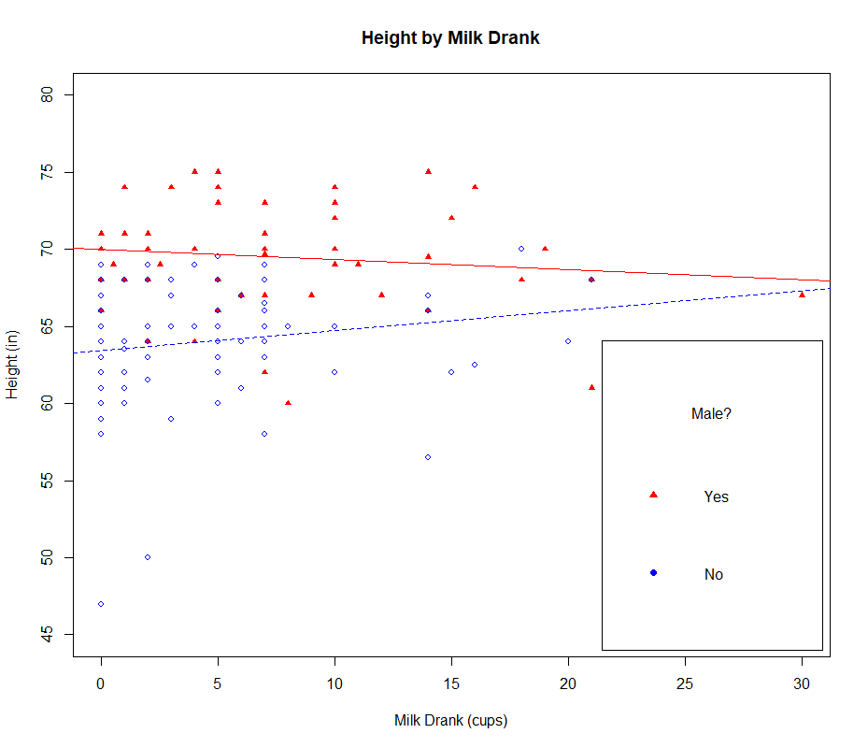

**Assumptions**

**Assumptions:**

* The heights of the UT 2020 students were assumed to be approximately normally distributed, so I reported the mean and standard deviation for center and spread. This is checked via a histogram.
* The study was not exactly a random sample because my survey was on a social media.
* The observations should be independent because the survey takers do not see others’ inputs.
* 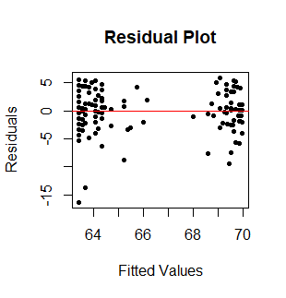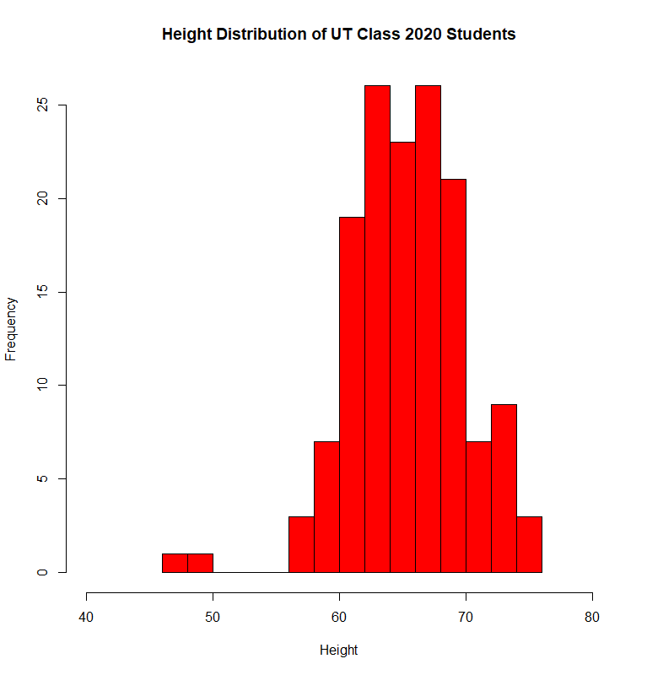The assumptions of numeric explanatory variables being linearly related to the response variable, residuals are normally distributed, and residuals have equal variance are not met as depicted by the residual plot showing a distinct pattern.

**Discussion**

**Interpretation:**

* Controlling for milk drank, male and female measure significantly differently for heights (t = 164.567, df = 142 p = 1.11e-13). On average, males have a height 5.526 inches taller than those of females while holding milk drank constant.
* Controlling for sex, milk drank is not a significant predictor of height (t = 1.637, df = 142,

p = .1038). On average, for each cup of milk drank, height increased by 0.130 inches, while holding sex constant.

* We found no significant interaction between sex and cups of milk drank on height

(t= -1.736, df = 142, p = 0.0847). The effect of cups of milk drank on height is the same for males and females.

I did not expect the effect of cups of milk drank on height to be the same for both males and females. However, my other assumptions of males, on average, being taller and cups of milk positively correlating with height was met, but milk drank resulted in not being a significant predictor of height.

**Limitations:**

* There was a volunteer bias because it was an optional survey
* My data failed the random sampling assumption.
* A confounding variable is number of calories one consumes which would influence a person’s height in their period of growth. Someone who had to drink only milk for nutrition might have less to eat and thus grew less and weakening the relationship between cups of milk drank and height.

**Implications and Future Research:** For the UT class of 2020, males are significantly taller than females as expected. The effect of milk on height for both sexes appear to be the same. There is evidence to suggest milk can help a person grow but it may also be the fact that it is not the superfood for height as we once thought. To expand on this study, I would include the other years of graduation of UT. This would help reduce bias in some graduating class years. Though UT is diverse, it would be helpful to get data on another university in a different region of the US to infer about a more general population.

**References**:

* Li, M., Liu, P., Li, Y., Qin, Y., Liu, Y., & Deng, H. (2004, February 27). A Major Gene Model of Human Height. Retrieved from <https://www.nature.com/articles/jhg200425>
* How much of human height is genetic and how much is due to nutrition? (2006, December 11). Retrieved from https://www.scientificamerican.com/article/how-much-of-human-height/